**User guide for Zoom sign-up and meeting access**

**Step: 1**

* Visit the following URL <https://zoom.us/>

**Step: 2**

* Click on the Sign-up button

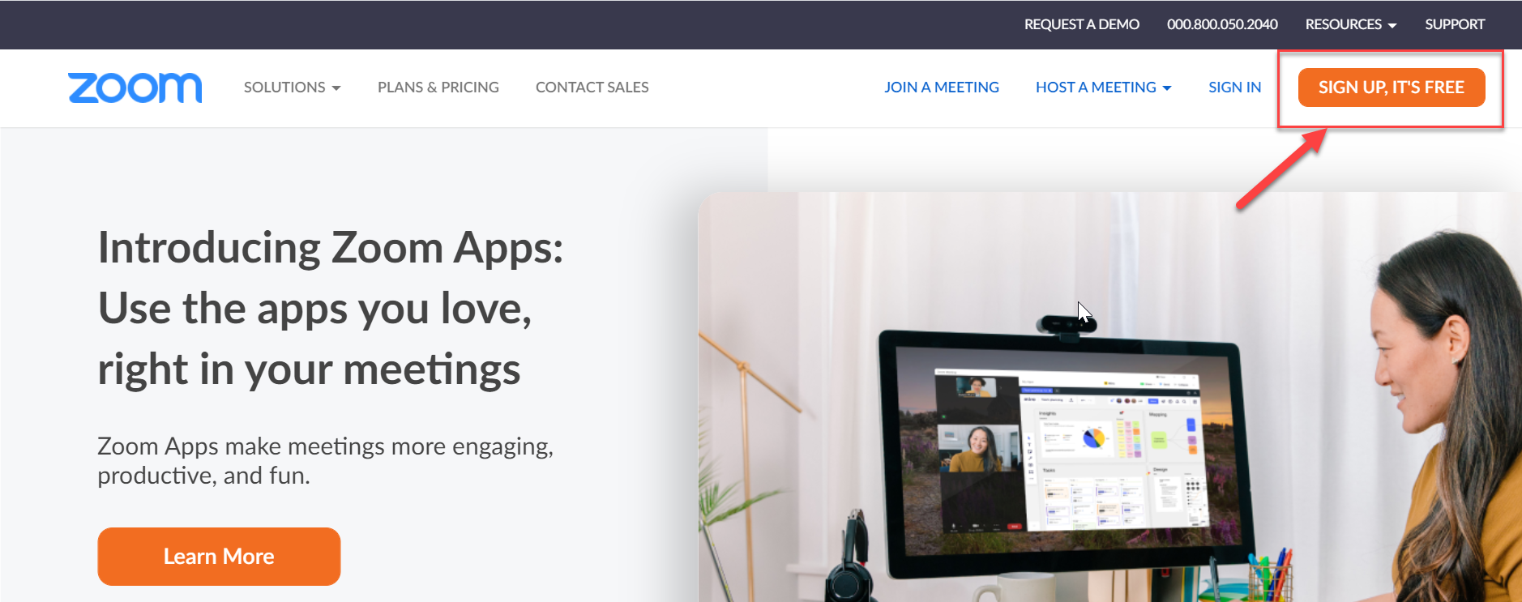

**Step: 3**

* Enter your date of birth and hit continue

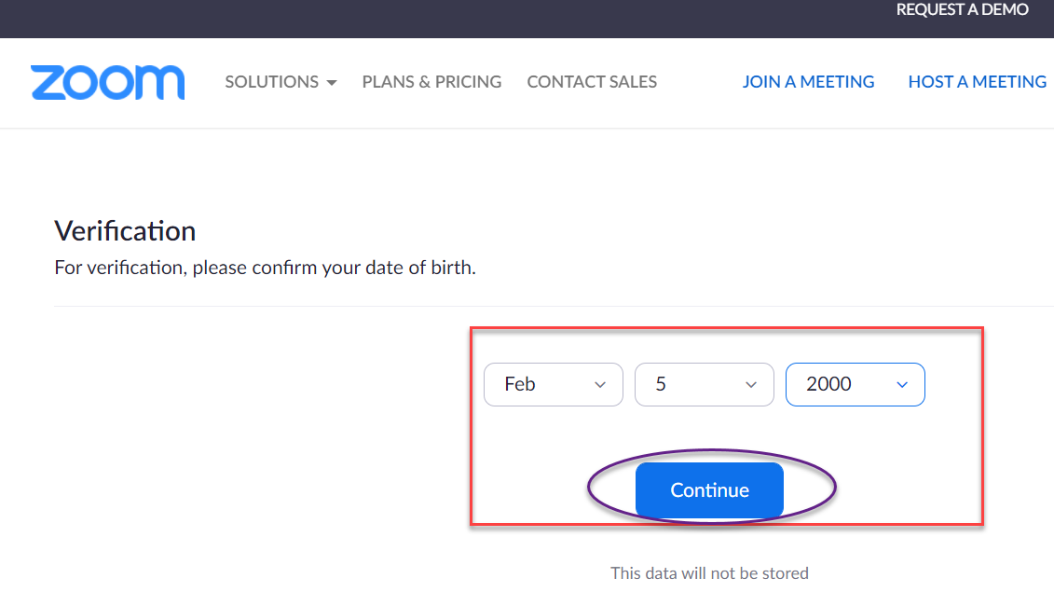

**Step: 4**

* Copy the email address under the profile section of your RevaturePro account

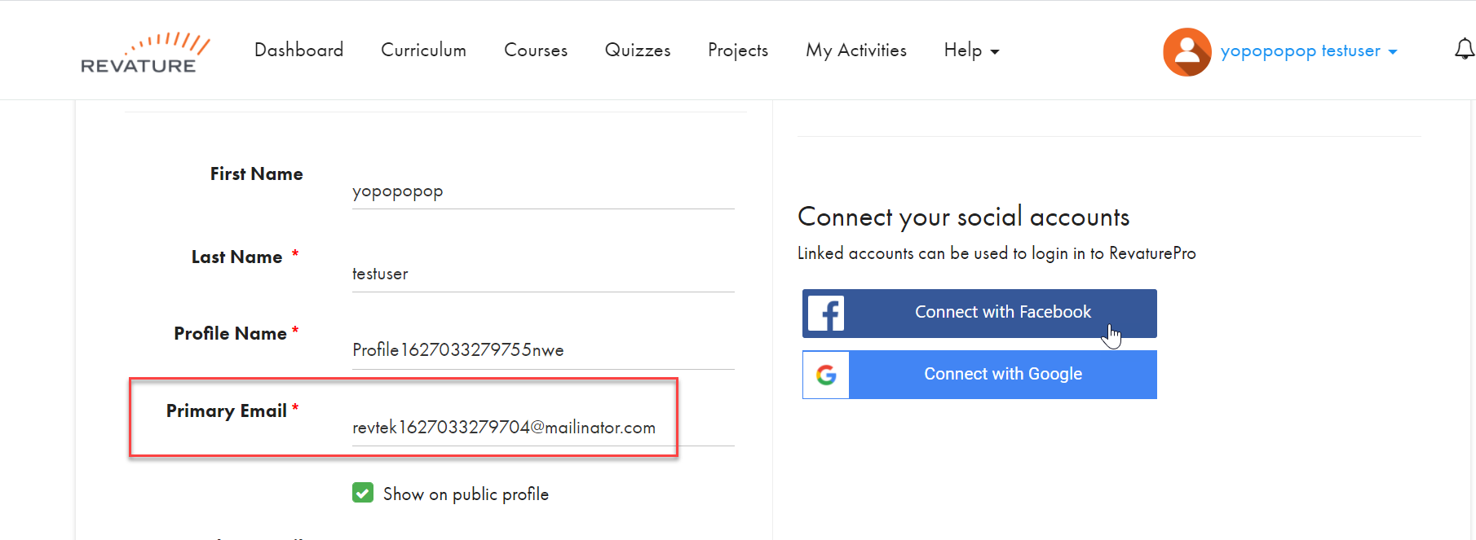

* Paste it in zoom and click signup
* Alternatively, you can use the other sign in options such as google and Facebook but make sure it is same as your RevaturePro training email address.

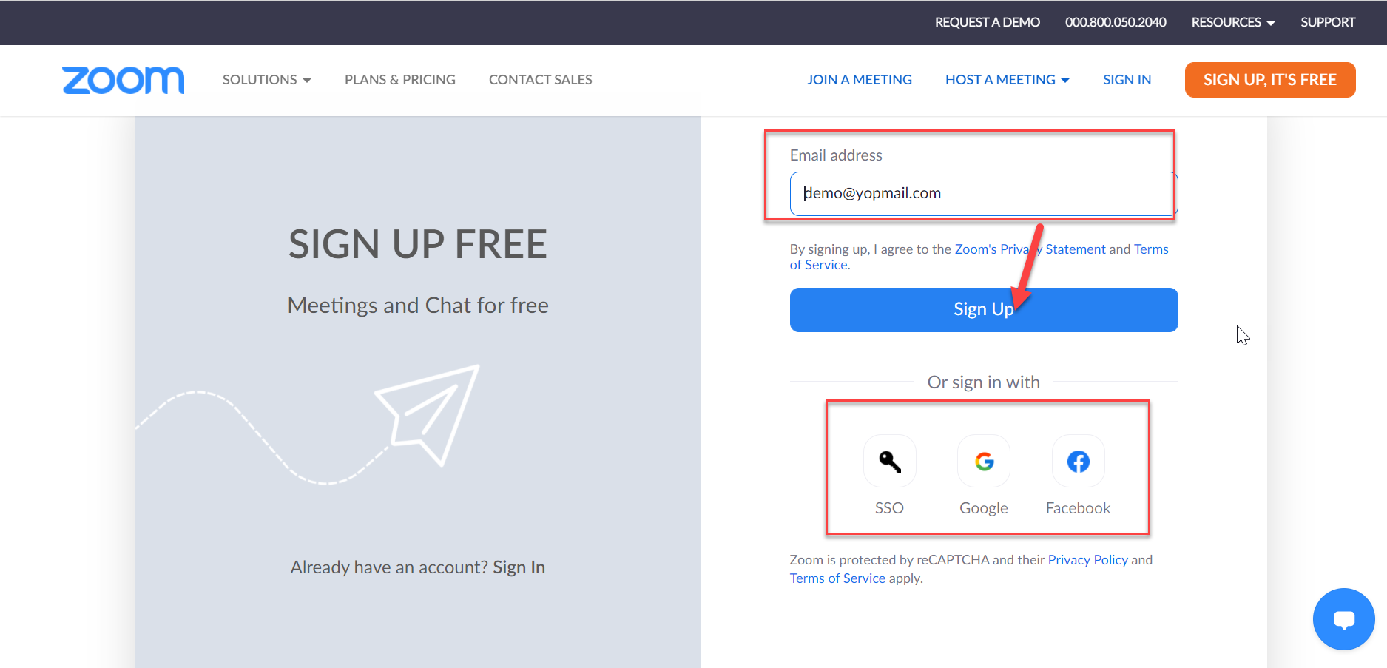

**Step: 5**

* Once you sign up, an activation email will be sent to your inbox
* Click the activate account button on the email

**Step:6**

* Enter requested details such as first name, last name and set a password
* **You have now successfully created your zoom account**

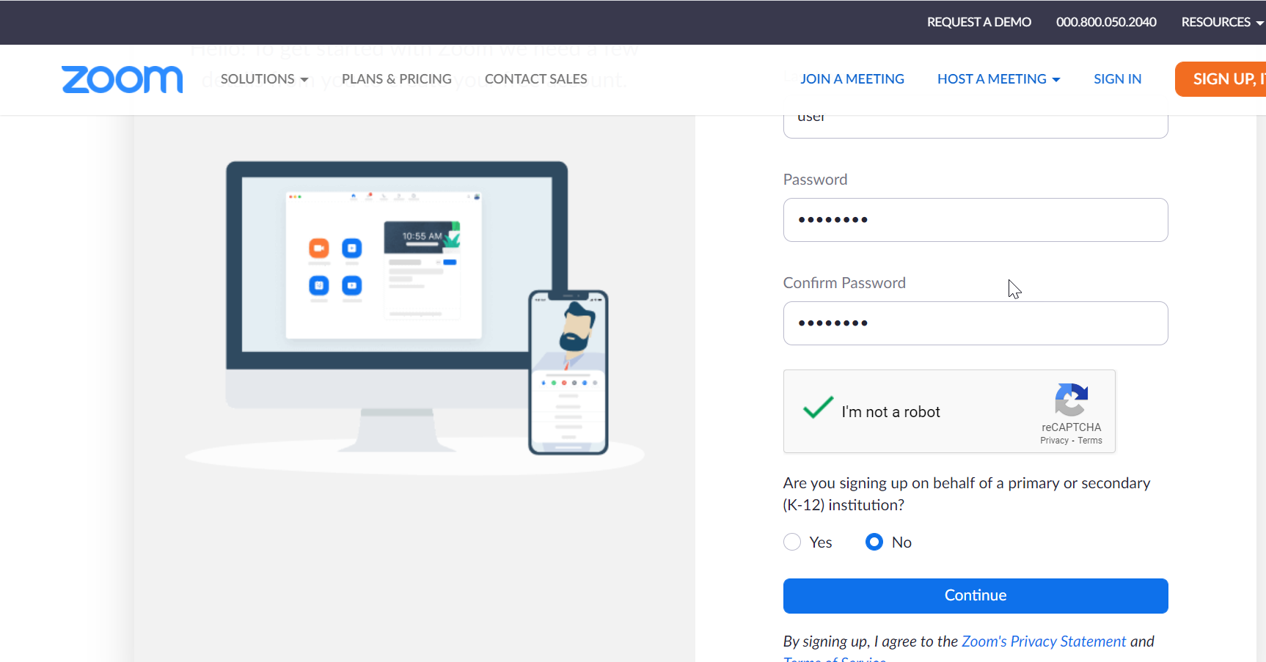

**Step:7**

* Now, copy and paste the meeting link that was shared with you from Revature on a new tab from the same browser
* Click open zoom meetings and wait for your trainer to let you in.

